**Guide to how to Run SLAS**

**Step 1:** Get Raspberry Pi and Set up Rasberry Pi OS

|  |  |
| --- | --- |
| Go to: | <https://www.raspberrypi.com/software/> |

|  |
| --- |
| Screenshot of Raspberry Pi Imager  Figure 1: Raspberry Pi Imager Software |

**Download** Raspberry Pi Imager and use the software to install any OS [***Raspberry Pi Full Desktop or Lite***]

**Insert** the SD Card into PC and use the RPi Imager software to download the OS and install automatically.

**Select** the OS from the list and then **select** your SD card from ***storage*** option and then click ***WRITE***.

For this tutorial we will install ***Raspberry Pi OS lite***.

|  |
| --- |
|  |
| Figure 2: Rasperry Pi Imager Operating System Choice |

**Step 2:** Enable SSH and Setup WLAN before first boot

**Unplug** the SD Card and **Plug it back** into your windows machine. You will see a new drive called ***boot*** on the computer.

|  |  |
| --- | --- |
| On the mounted drive (named: ***boot***):  **Create** an empty file called ‘***ssh’***  ***Using command shell***:  **Right click** in the folder and click “Open in Windows Terminal” |   *Figure 3: Open in Windows Terminal* |

Or if you do not see that option, find windows PowerShell from windows start menu and navigate to that folder using cd commands and then type in the following command to create and empty file named ‘ssh’

|  |
| --- |
| $null > ssh |

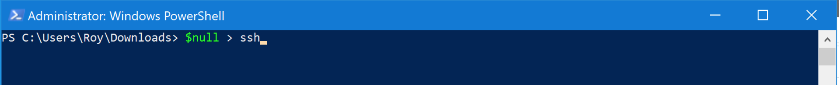

Then do the same for wpa_supplicant.conf like below:

|  |
| --- |
| $null > wpa_supplicant.conf |

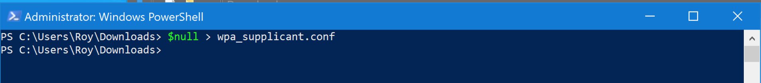

Right click on the created wpa_supplicant.conf and open with Notepad in windows. And then paste the following codes in there and save the file. Remember to change the placeholders for Wi-Fi Name and WIFI Password to your Wi-Fi name and password like below:

|  |
| --- |
|  |

|  |
| --- |
| country=US  ctrl_interface=DIR=/var/run/wpa_supplicant GROUP=netdev  update_config=1  network={  scan_ssid=1  ssid="your_wifi_ssid"  psk="your_wifi_password"  } |

|  |
| --- |
| Graphical user interface, text, application  Description automatically generated  Figure 4: wpa_supplicant.conf in Notepad |

***N.B: Location of these two files will be in your BOOT drive.***

**Step 3:** Raspberry Pi First Boot

**Plug** the SD card inside the raspberry pi and boot it

After the first boot of the raspberry pi, we need to expand the file storage to full SD card to have more available space for our application.

*The first option available in the* ***raspi-config*** *tool is* **Expand Filesystem***. By default, the size of the Raspbian root file system is 2GB. If you have an SD card with more capacity, the portion of your disk space will be unused. This option enables you to expand your Raspbian installation to fill out the rest of the SD card, giving you more space to use for files.*

In the terminal type:

|  |
| --- |
| sudo raspi-config |

|  |  |
| --- | --- |
| Graphical user interface, text, application  Description automatically generated  Figure 5: raspi-config main menu | Graphical user interface, text, application  Description automatically generated  Figure 6: raspi-config file expand option |

**Select** *Advanced Options* *>* *A1 Expand Filesystem*

**Finish** and **Reboot** the pi with command:

|  |
| --- |
| sudo reboot |

**Step 4:** Connect with SSH

**Get** the Raspberry Pi’s IP Address with the command:

|  |
| --- |
| ifconfig wlan0 |

|  |
| --- |
| Text  Description automatically generated  Figure 7: Raspberry Pi IP Identification |

Now you can **disconnect HDMI or Monitor** to connect with ***SSH***.

On your Windows/Mac/Linux computer open terminal [*Powershell/Command Prompt in windows*]

Now type:

|  |
| --- |
| ssh <user>@<ip> |

Here I typed:

|  |
| --- |
| ssh [pi@192.168.123.20](mailto:pi@192.168.123.20) |

|  |
| --- |
|  |
| **Input** the password of the raspberry pi. ***Default password:*** ***raspberry*** |
|  |
| **Terminal** of the raspberry pi will appear for us to work on |

**Step 5:** Update software sources and packages

**Type** in terminal:

|  |
| --- |
| sudo nano /etc/apt/sources.list |



This will open nano – a text editor that will help edit the software sources

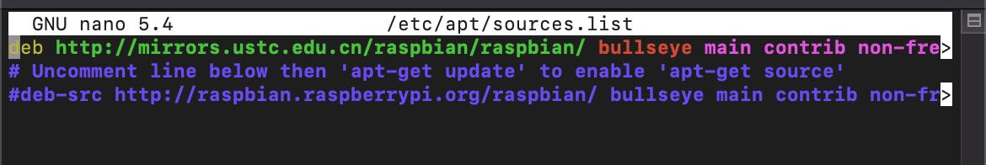

Change the first part of the URL [GREEN PART] to

|  |
| --- |
| <http://mirrors.ustc.edu.cn/raspbian/raspbian> |

Press **CTRL + O to save** the file and press **CTRL + X to exit** the editor

Again, Type in terminal:

|  |
| --- |
| sudo nano /etc/apt/sources.list.d/raspi.list |



Change the first part of the URL [GREEN PART] to

|  |
| --- |
| http://mirrors.ustc.edu.cn/archive.raspberrypi.org/debian/ |

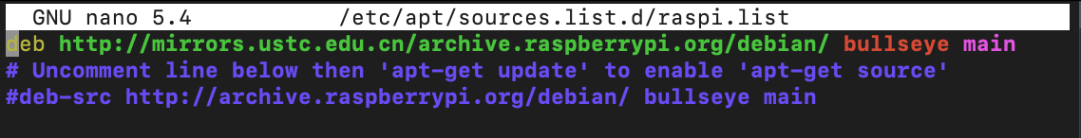

Press **CTRL + O to save** the file and press **CTRL + X to exit** the editor

Now in terminal type:

|  |
| --- |
| sudo apt update && sudo apt upgrade -y |

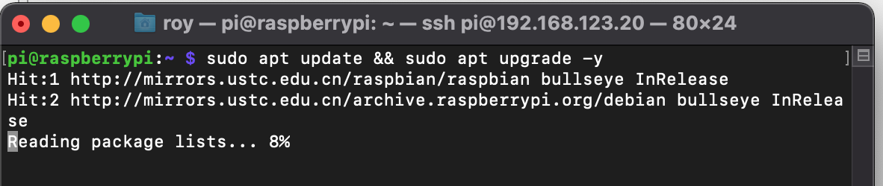

After the update finishes, type:

|  |
| --- |
| sudo reboot |

This will reboot the pi

Re-login with ssh once the system reboots

**Step 6:** Install LAMP stack on Raspberry Pi

In the terminal type:

|  |
| --- |
| sudo apt install apache2 php mariadb-server php-mysql phpmyadmin -y |

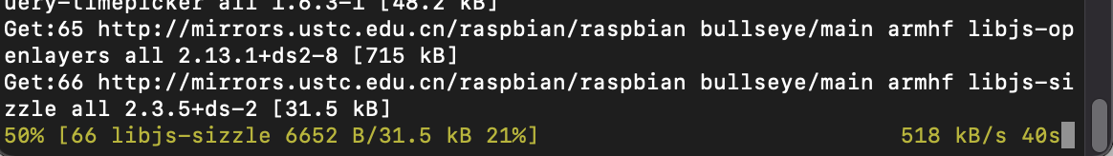

Wait for it to finish and complete all the required prompts as follows:

|  |  |
| --- | --- |
|   **Select** Apache2 with ***space*** key |   **Select** **‘*YES’*** to create database for ***phpmyadmin*** |

|  |  |
| --- | --- |
|   **Set** **Password** for phpmyadmin user in **MySQL**  Here we set: ***toor*** |   **Repeat** the password in the next screen |

**Step 7:** MySQL Permission Set

Type in terminal:

|  |
| --- |
| sudo mysql |

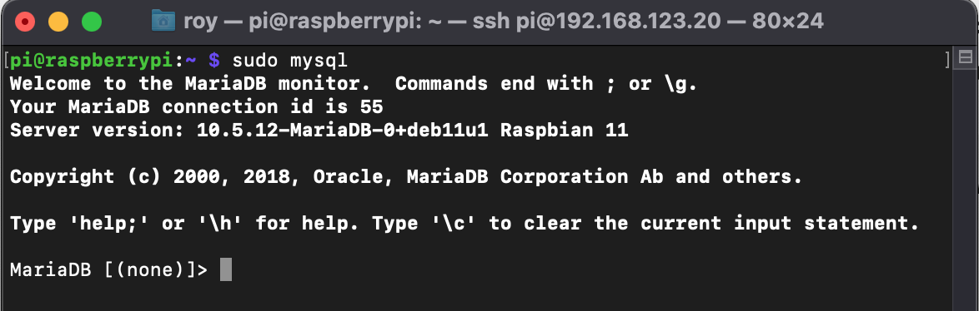

Type:

|  |  |
| --- | --- |
| **Code to run** | **Function** |
| grant all privileges on *.* to phpmyadmin@localhost; | This command will grant phpMyAdmin all priveleges to be accessed from localhost |
| GRANT ALL ON class_qr.* to 'phpmyadmin'@'0.0.0.0' IDENTIFIED BY 'toor'; | This command will grant phpMyAdmin all priveleges to be accessed from 0.0.0.0 |
| GRANT ALL ON class_qr.* to 'phpmyadmin'@'<REMOTE-IP/HOSTNAME>' IDENTIFIED BY 'toor'; | This command will grant phpMyAdmin all priveleges to be accessed from REMOTE-IP/HOSTNAME of requested device |
| GRANT ALL ON class_qr.* to 'phpmyadmin'@'raspberrypi.lan' IDEN  TIFIED BY 'toor'; | This command will grant phpMyAdmin all priveleges to be accessed from raspberry pi itself |
| FLUSH PRIVILEGES; | This command will flush privileges and apply the new changes |
| Exit; | Exit MySQL console |

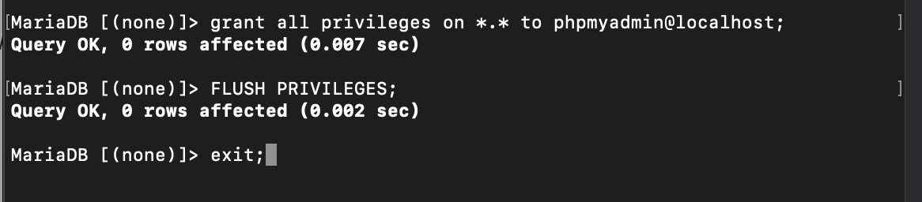







Run in terminal:

|  |
| --- |
| sudo phpenmod mysqli |

Run the following to edit mysql permissions to access:

|  |
| --- |
| sudo nano /etc/mysql/mariadb.conf.d/50-server.cnf |

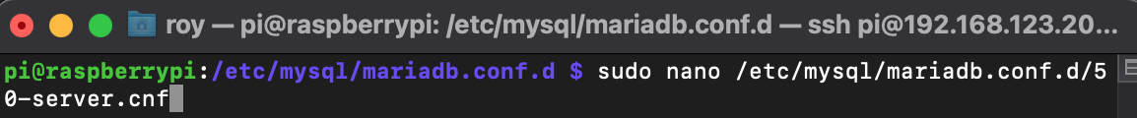

Scroll down and change the configuration as follows:

|  |  |
| --- | --- |
|  |  |

Run:

|  |
| --- |
| sudo service mysqld restart |



**Step 8:** phpMyAdmin login test

Open browser and type in

|  |
| --- |
| http://<ip-address>/phpmyadmin |

Here we typed:

|  |
| --- |
| <http://192.168.123.20/phpmyadmin> |

|  |
| --- |
|  |
| Figure 8: phpmyadmin login page |

If it comes, we are good to go.

**Step 9:** Upload database backup through phpMyAdmin

**Login** to phpMyAdmin

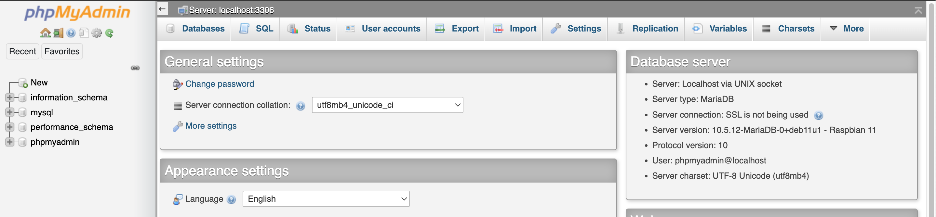

**Click** Import

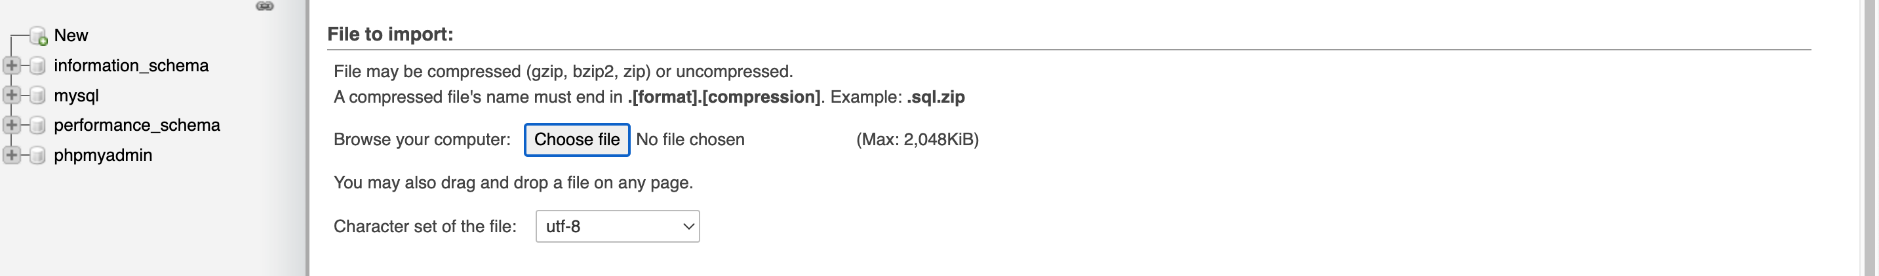

**Select** ‘class_qr.sql’

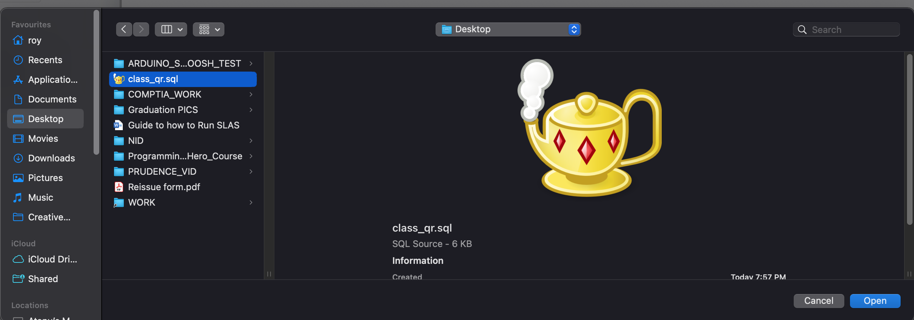

**Scroll down** and click ‘*Go’*

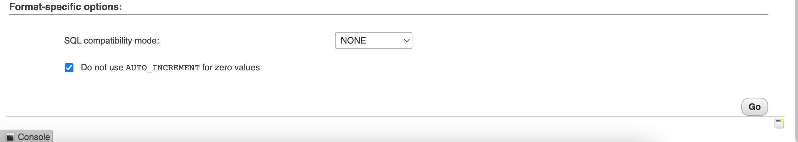

You shall see a green tick with the text ‘Import has been successfully finished’

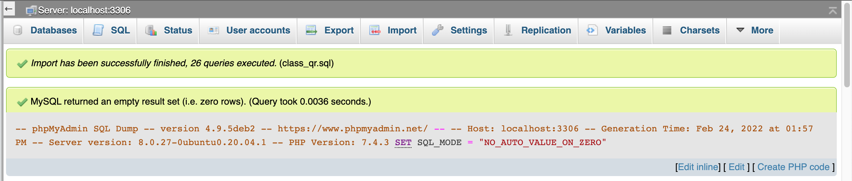

|  |  |
| --- | --- |
|  | You can check your database now as shown here in the side panel |

**Step 10:** Download IntelliJ Idea Community and Install it

|  |  |
| --- | --- |
| **Go** to Link: | <https://www.jetbrains.com/idea/download/> |

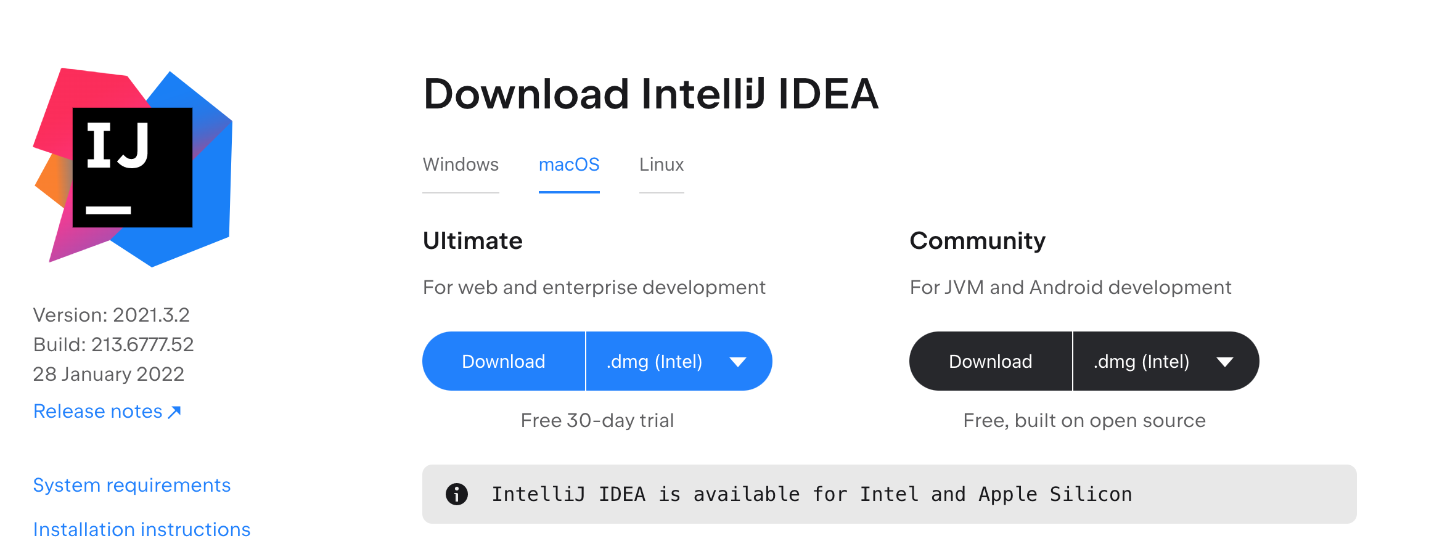

After downloading **install** it

**Step 11:** Open SLAS Project with IntelliJ idea and update packages for the project

**Open** the project with IDEA

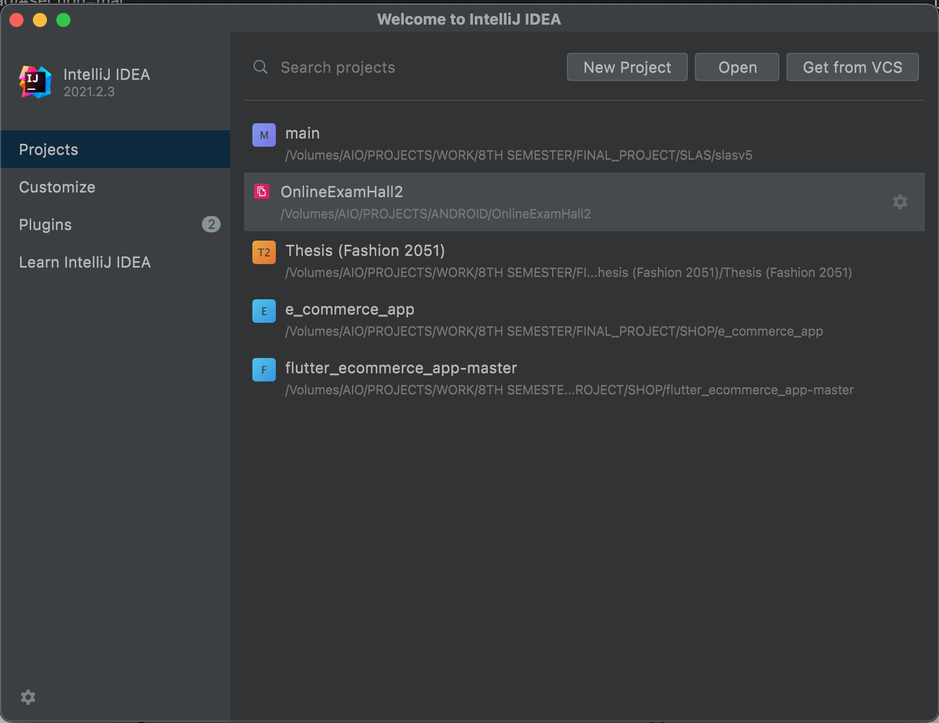

**Click** Open

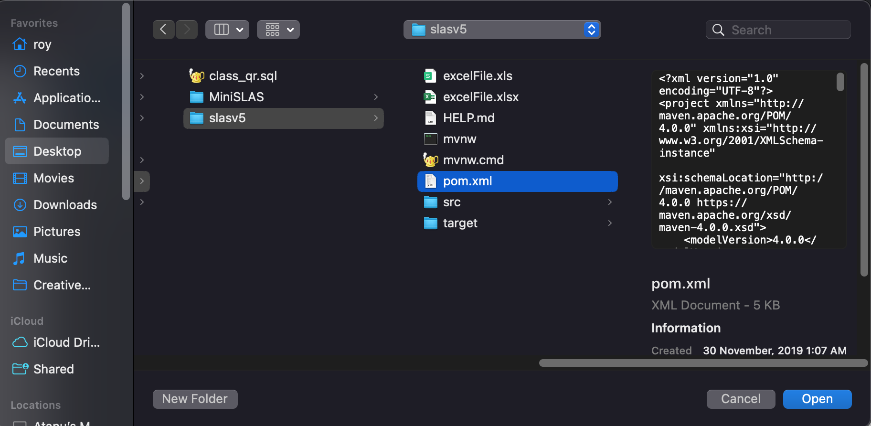

**Select** the pom.xml and then click on ***Open as Project***

Once the project opens it will look like this

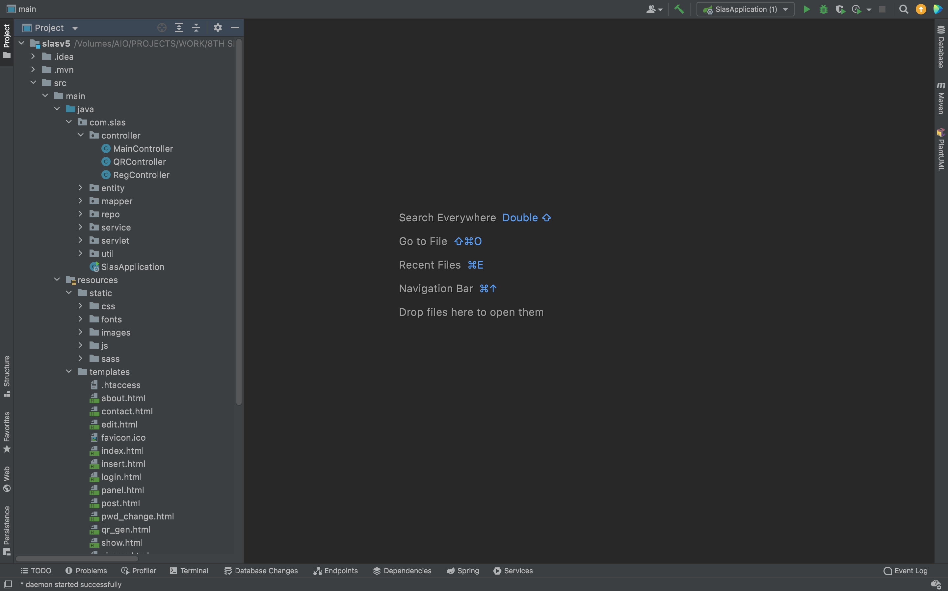

Let it finish updating packages so that we may be able to run it

**Step 12:** Change SLAS current IP to Pi Database IP

**Open** MainController.java file and go to line 136

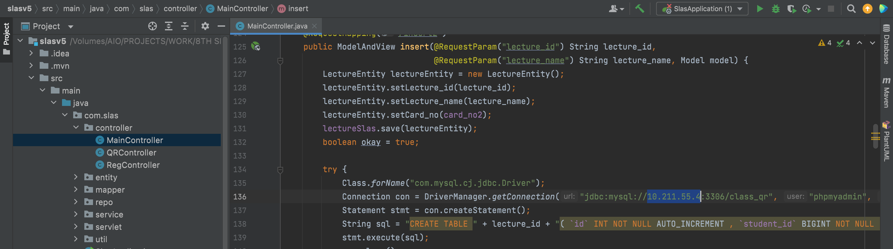

**Find** the current IP address

Here it is: ***10.211.55.4***

Go to **Edit > Find > Replace in Files**

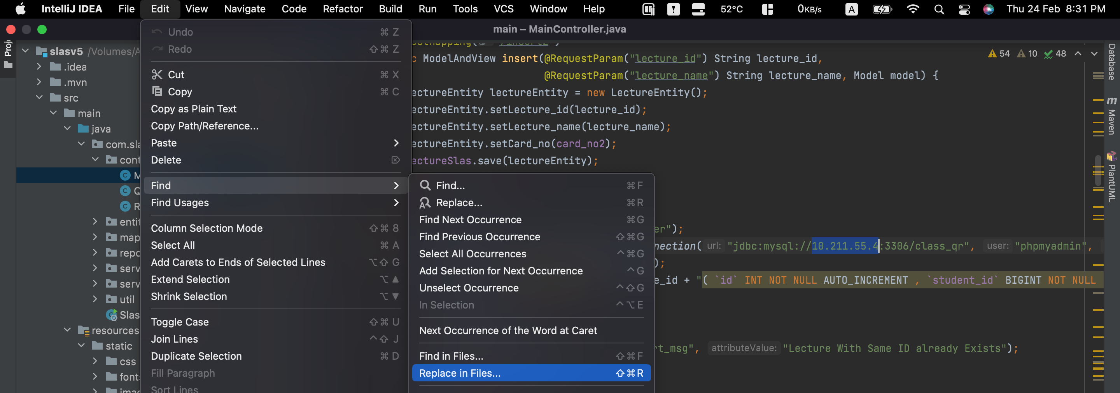

**Paste** like this:

|  |  |  |
| --- | --- | --- |
| **Location** | **Info** | **Example** |
| *First box:* | *CURRENT IP* | *10.211.55.4* |
| *Second Box:* | *NEW IP* | *192.168.123.20* |

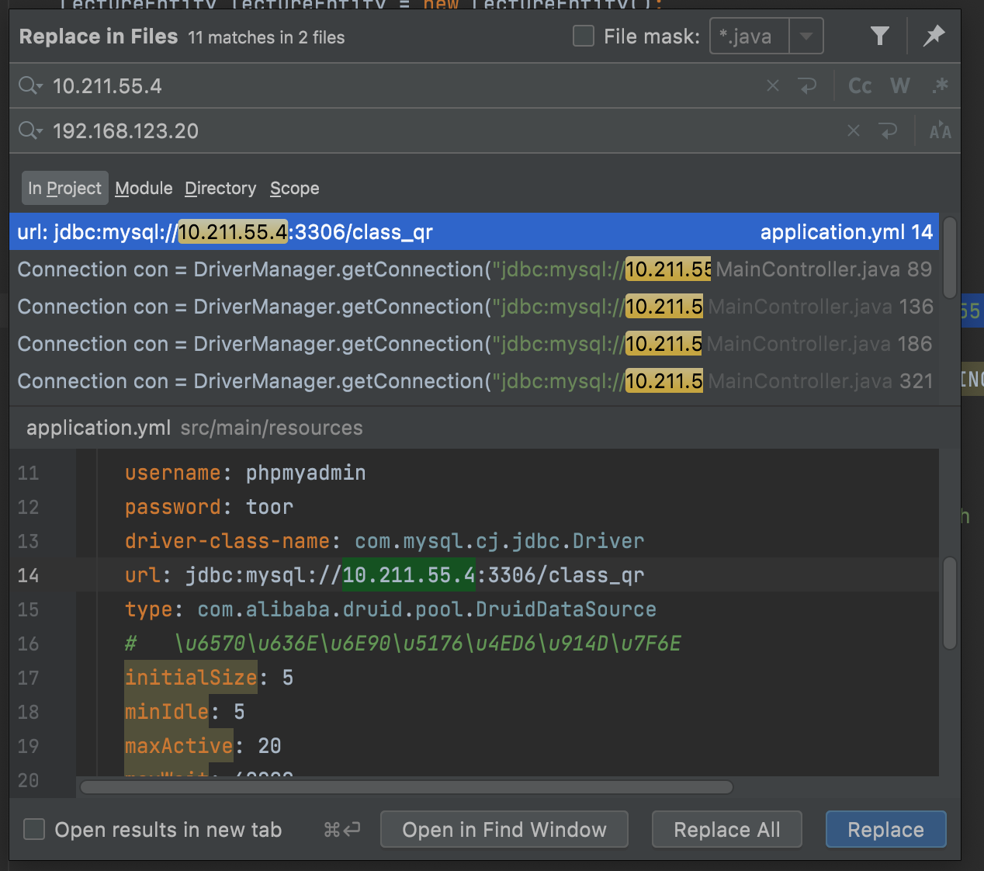

**Click** ‘Replace in all files’ at the bottom of the dialog box



The same process goes for Username and password

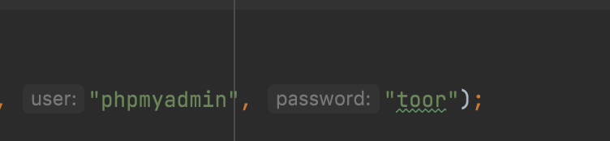

*Change all instances of username and password*

*N.B.: For convenience keep the same username and password at the time of installing LAMP stack on the raspberry pi*

Once that’s done, we will compile the project

**Step 13:** Compile SLAS Package

**Click** maven on the right side of the screen

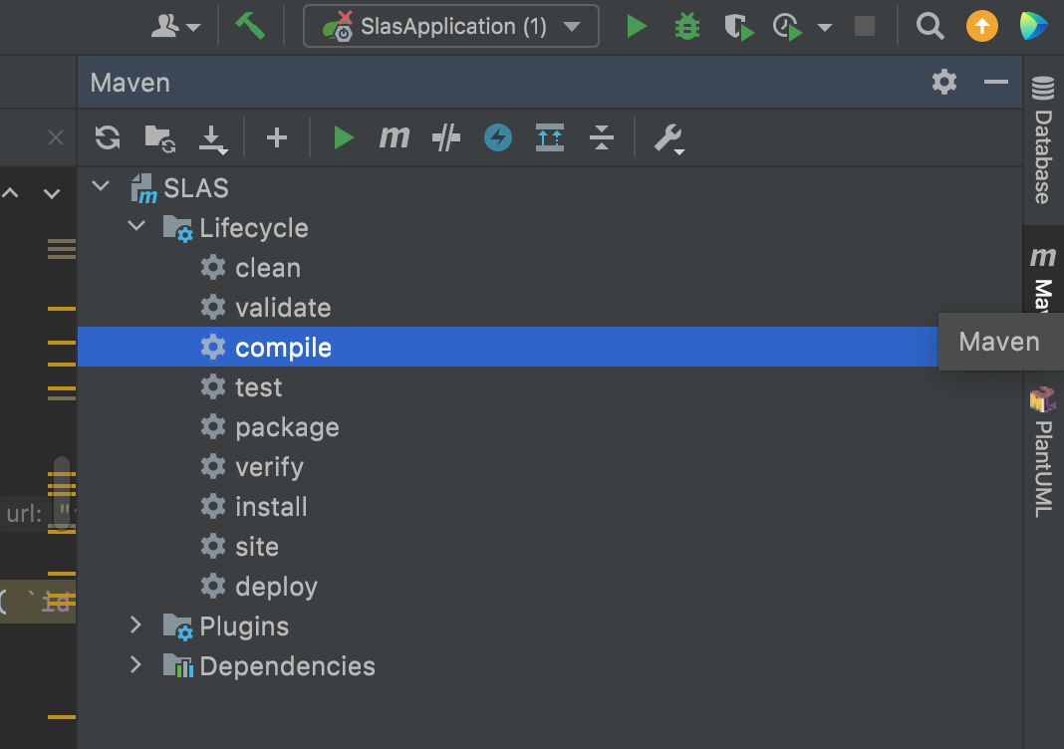

**Click** on Compile to compile an executable JAR file for Deployment

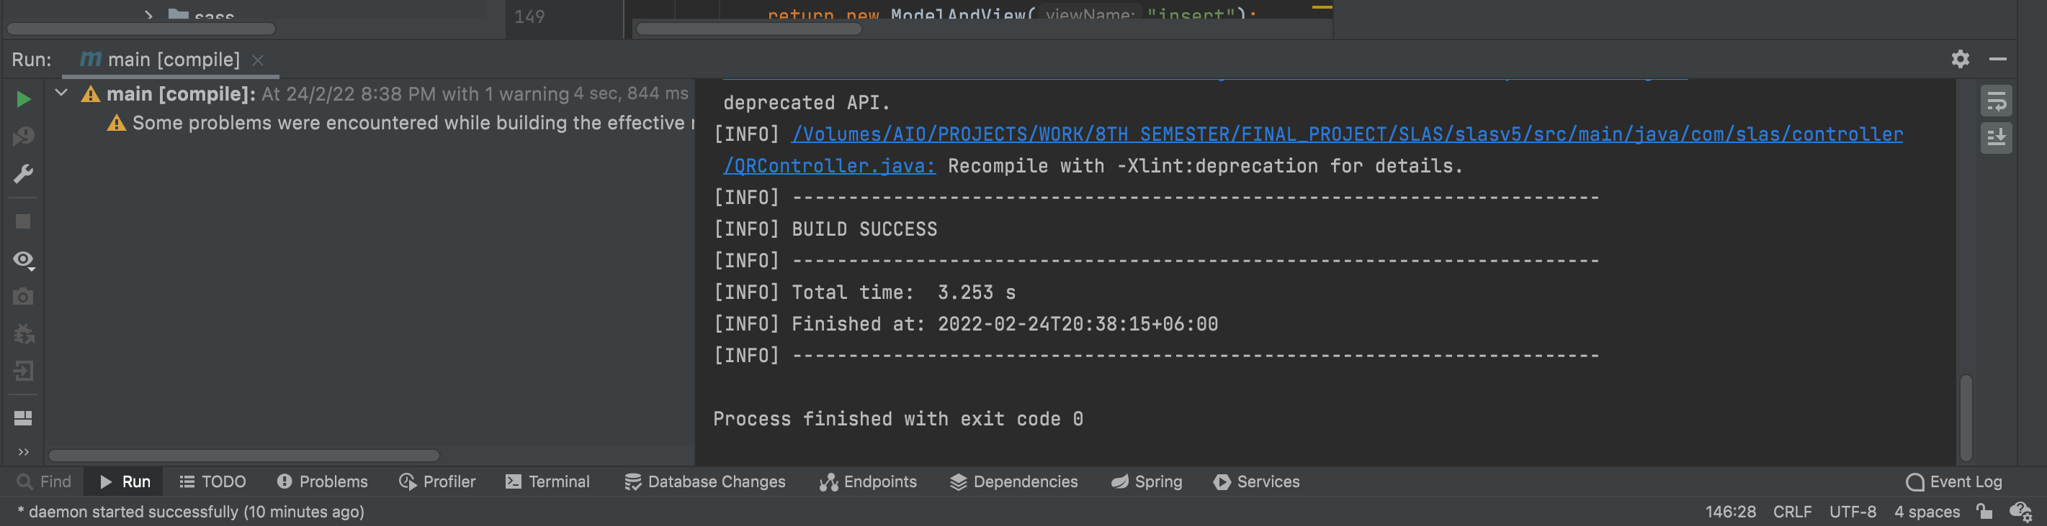

If compile succeeds, then click on package to pack it into a Jar file

|  |
| --- |
|  |
| Click on ‘**package**’ from the maven menu |
|  |
| See the below terminal and look out for ‘**BUILD SUCCESS**’ |
|  |
| Output file is in 🡪 **Source Directory 🡪 target 🡪 main-x.x.x-SNAPSHOT.jar** |

**Step 14:** Install JAVA on Raspberry Pi

Run in Terminal:

|  |
| --- |
| sudo apt install openjdk-8-jdk -y |

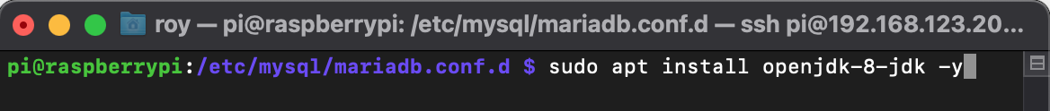

|  |  |
| --- | --- |
| Text  Description automatically generated  Installation Ongoing | Text  Description automatically generated  Installation Completed |

Once completed we can test if Java is working by typing this in terminal:

Java

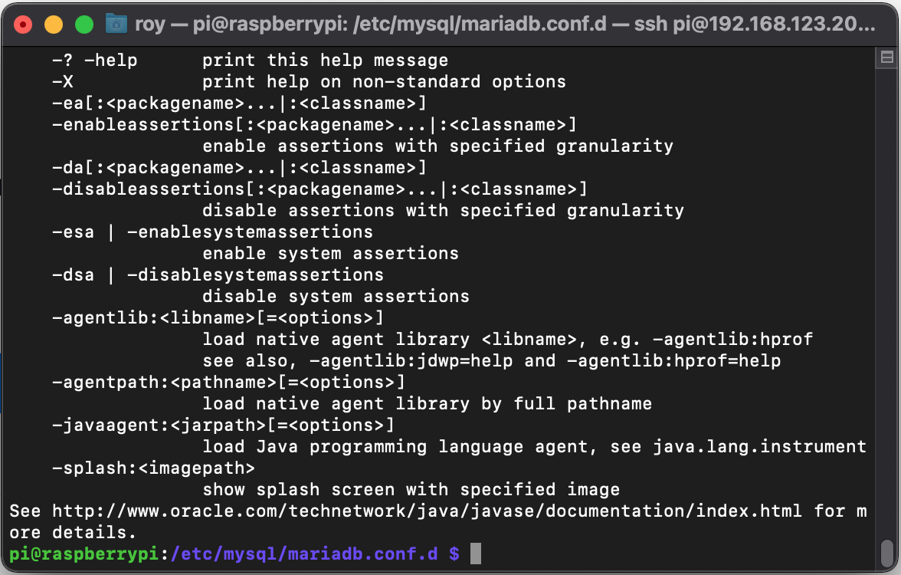

If you see something like this come up then java has been successfully installed.

**Step 15:** Install JAVA on Raspberry Pi

Copy over the file (main-0.0.1-SNAPSHOT.jar) to the raspberry pi using Filezilla

<https://filezilla-project.org/download.php>

Download and install this software to make it happen

***N.B. If you have install Raspbian Full Desktop or have any other desktop environment you can use a pendrive and copy it to the Home folder. Even on the lite version of the OS you can use the ‘cp’ command to copy the file from pendrive to the home folder. Here we show it with filezilla.***

Open Filezilla and paste this to the top bar

|  |  |  |
| --- | --- | --- |
| **Option** | **Info** | **Example** |
| Host: | sftp://<IP-ADDRESS-OF-PI>/ | Sftp://192.168.123.20 |
| Username: | <USERNAME-OF-PI> | Here: **pi** |
| Password: | <PASSWORD-OF-PI> | Here: **toor** |

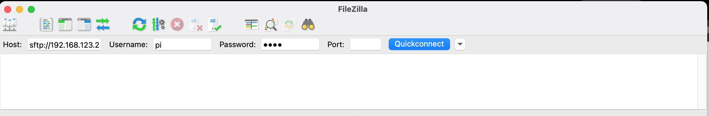

**Click** *Quickconnect*

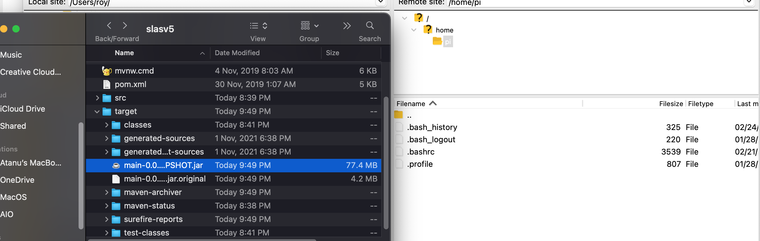

**Drag and drop** the file from File Manager to Filezilla

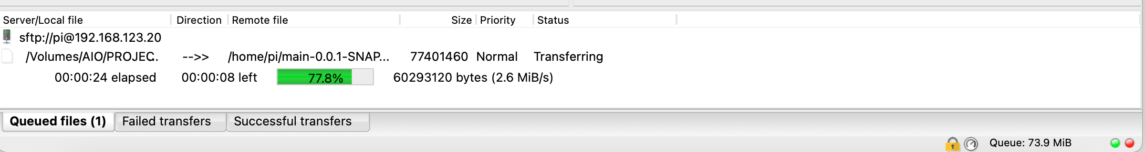

Wait for transfer to finish

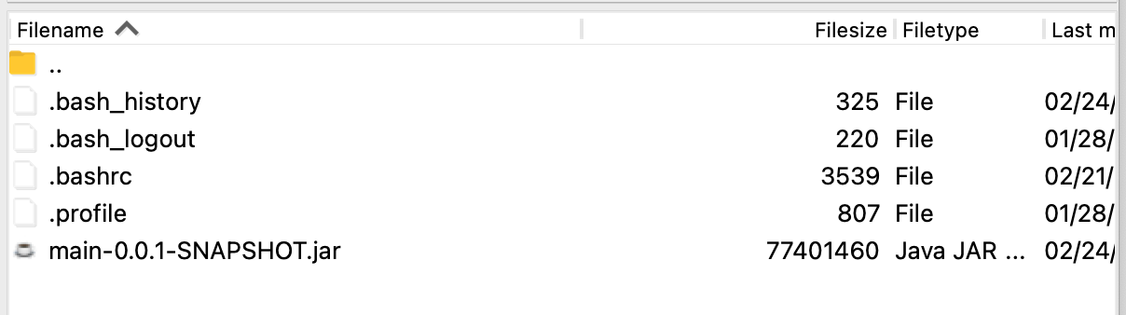

There is the file

We can check in terminal also. Run:

|  |
| --- |
| cd ~ |
| ls |

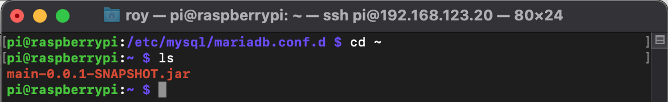

**Step 16:** Run SLAS Software Server

Run the following command in Terminal of Pi to run the software

|  |  |
| --- | --- |
|  | Wait for it to boot the software up |
|  | Once finished it will look like this  It will show started slasapplication in xx.xxx seconds |

**Step 17:** Open browser on the PI or Another computer on the same network

Type in the raspberry pi’s ip address followed by port 8080 to load SLAS Web

Here we put:

|  |
| --- |
| http://192.168.123.20:8080 |

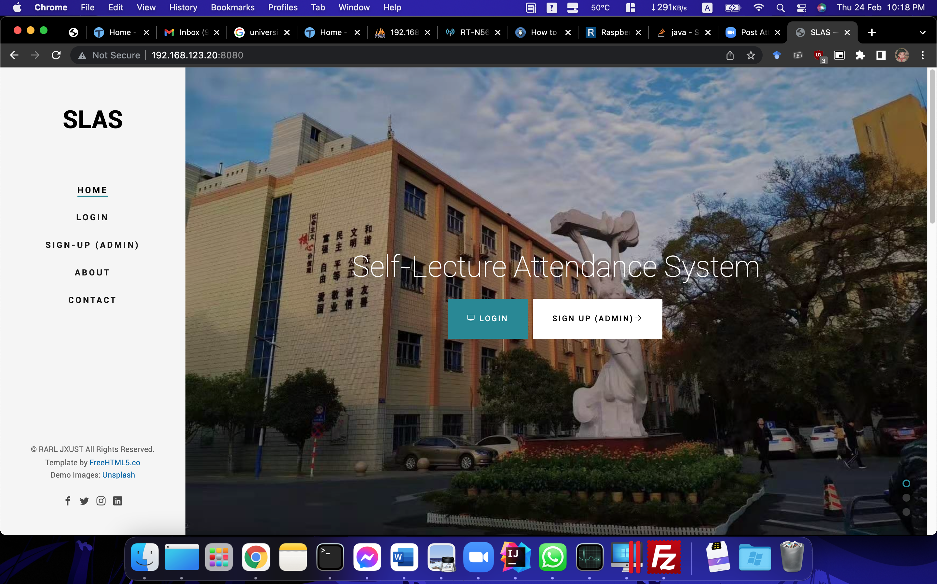

Now you can use it

**SLAS MOBILE (WECHAT MINI PROGRAM)**

**Step 1:** Download WeChat Devtools and install it

|  |
| --- |
| <https://developers.weixin.qq.com/miniprogram/dev/devtools/download.html> |

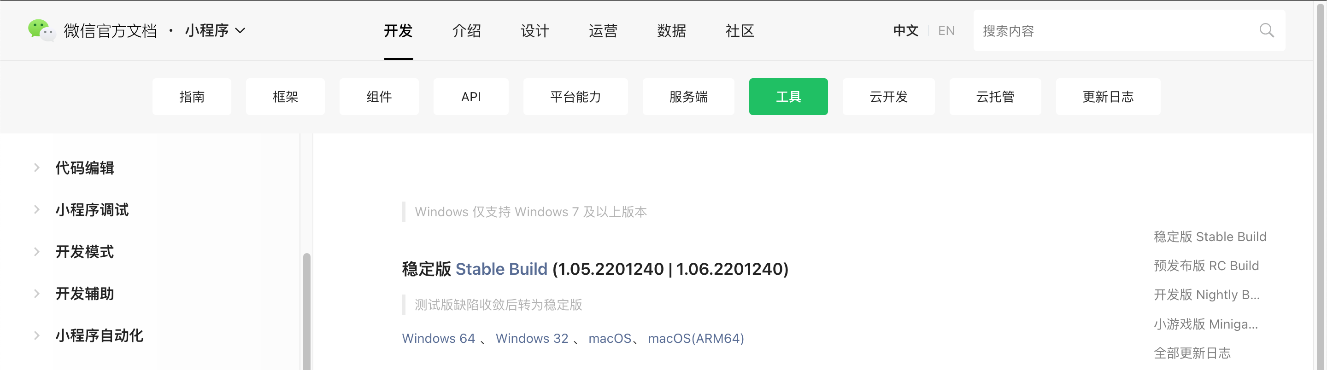

Install the stable build

**Step 2:** Open WeChat Devtools and import the project

Login to WeChat Devtools by scanning QR code

|  |  |
| --- | --- |
| Qr code  Description automatically generated  PC Login QR Code | Graphical user interface  Description automatically generated  Phone WeChat Confirmation |

Tap the green button on phone screen to confirm login



In the next page click Import and import navigate to the folder where MiniSLAS project is located. Select the root level of the project.

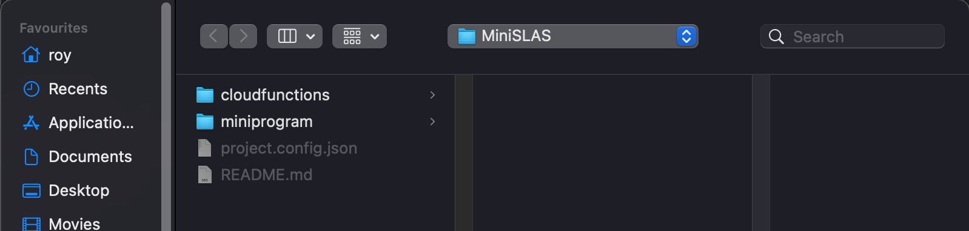

Select and let the IDE finish importing

In the next screen you will see

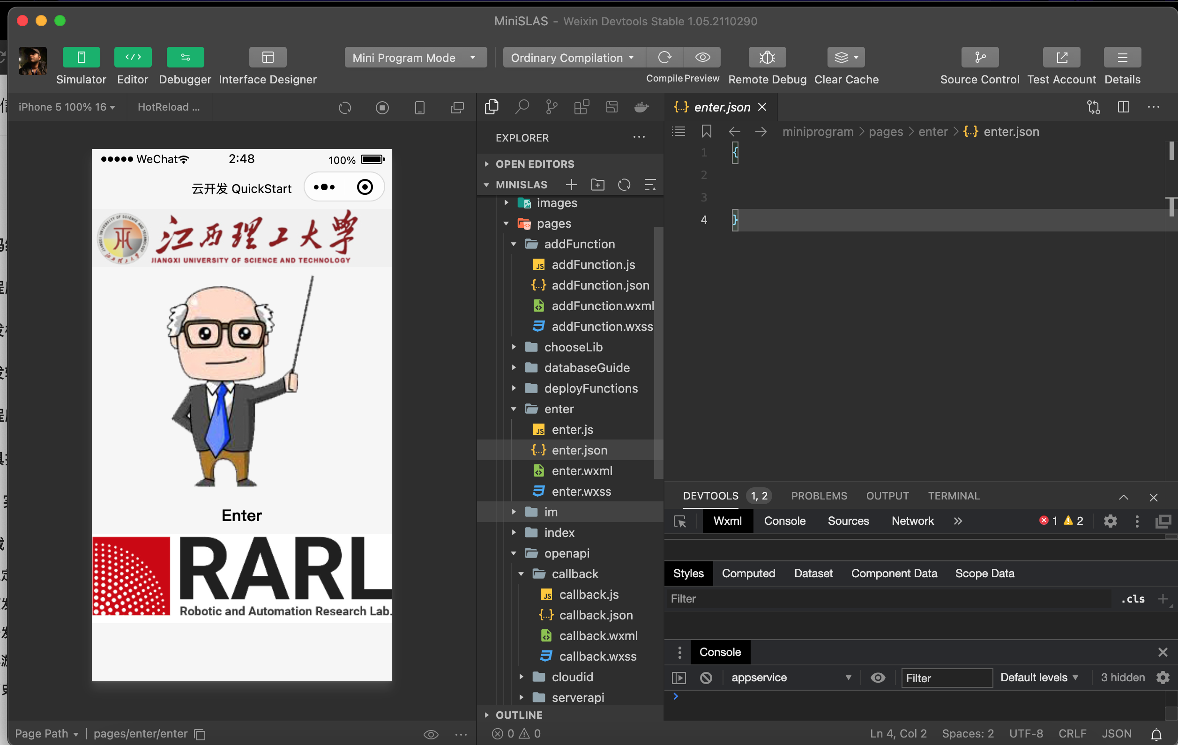

Now click on Preview on the top bar



Figure 9: Top Bar of the IDE

|  |  |
| --- | --- |
| Graphical user interface, website  Description automatically generated  Project being compiled | Qr code  Description automatically generated  Mini Program QR Code ready to be scanned |

**Step 3:** Scan with WeChat on phone to load the Mini program

|  |
| --- |
|  |

Enjoy using SLAS !!!!